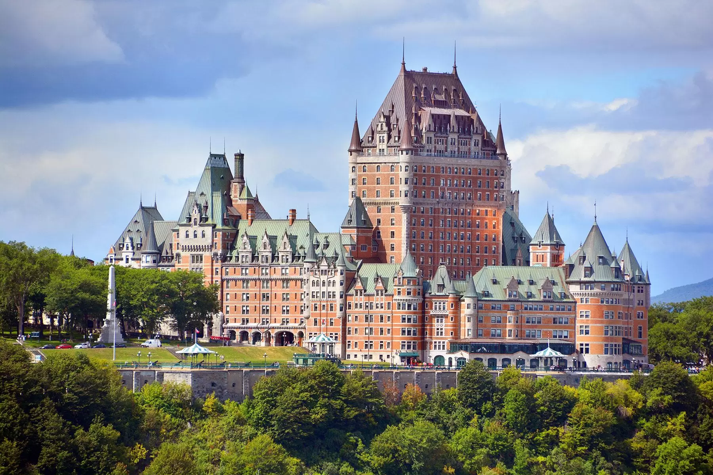
Canadian Financial Plan
Trip to Quebec City
Barfin

During the winter of 2019, my sister and I will be visiting Quebec City. From choosing Quebec City, I have always wanted to visit this location as I found it obtained a lot of historical figures. Being that the city was one of the first Canadian cities made, it still has a lot of the older influence left in the city. This means a lot of the architecture is known to be historical, which is one of the reasons I hope on visiting. Architecture is really important to me as I feel it changes the whole environment and atmosphere of a location. In saying this, I feel that the architecture in Quebec City has a lot of the formal French influence being very sharp and exquisite on the details. Some of the most popular tourist attractions include visiting the art museum MNBAQ which serves as the largest collection of Quebec Art. Musée national des beaux-arts du Québec houses a collection of more than 38,000 pieces of artwork. It features Quebec art from the 17th century to the present day. Another place that Quebec is known for is the Place Royale. It was built in 1608, where Samuel de Champlain created a fur trading post that soon grew into the capital of French America. The site is the largest surviving ensemble of 17th- and 18th-century buildings in North America. However, the most popular attraction has to be the city of Old Quebec. The city is home to farm markets and stone architecture from the 1800 hundreds. In saying this, it would be an adventure to actually go to Quebec and experience the culture. Further on, an activity I would like to partake in is visiting the Musée de la Civilisation. The museum is known for having hands-on workshops for the whole family on a wide range of current, historical events.

A lot of the costs were divided between me and my sister such as certain foods if we already ate that day, taxi fares and even gifts. With this, we were able to not spend over the limit by deciding we wanted to share each cost, and only getting 1 gift for others between the two of us. Also, by deciding to stay with our grandma, it meant that we didn't need to pay extra for a hotel, but it means that we had to share a room. In saying this, we mainly used public transportation such as busses as they were the most accessible and most affordable. The cost was $3.00 per person each time. However, places overseas such as when travelling to Ill d'Orléan's required for taking a taxi as buses didn't go over the bridges. Taxis ranged from $50 - $70 per ride but often they could be split between 2 people equaling around $25-35. Though when my grandma travelled with us, she drove us in her car. We tried to minimize the need for transportation as much as possible by often walking to places that are short distances such as 20 minutes or 7 minutes. In saying this, we didn't spend a lot on transportation by using our resources around us.

In saying this we will be leaving YVR (Vancouver) December Friday the 13th at 1:00 and arriving at 10:54 in Quebec City (YQB) through Air Canada on flight AC 398 and AC 8708. The flight includes above-average legroom with 81 cm, WIFI, USB outlets and on-demand videos. We have decided to stay with our grandma as she has extra bedrooms and we are going to try and catch up for lost time. Also, it was decided by our parents that it would try and help lower the costs of hotels. Once arriving, our grandma would pick us up at the airport and drive us back to her house which is located at 495 rue des Commissaires Est - Le Gordon - Par Construction SR in Saint Roch. From it already being the evening, my sister and I decided to head off to bed.

On the morning of Saturday, December 14th, we wake up to breakfast made by our grandma. One the first official day, after breakfast we are still relaxing and catching up with our grandma. Near the afternoon, we decided we wanted to go out and explore Old Quebec Farmers market located at 250-M Wilfrid-Hamel Blvd, Quebec City. Strolling through, we got to see a lot of the historical aspects, as well as artisan made products. When we got hungry, we went for lunch at a restaurant called the Lebanese Galette located at 641 Grande Allée E street by walking. In which I got myself an $8.75 spinach and cheese wrap. Taking the bus back to the market, we decided we wanted to explore the whole market a little bit better. In saying this, we decided to buy shirts and keychains for family and friends.

Further on, some other attractions that we visited were the Quartier Petit Champlain mall located 61 Rue du Petit Champlain, Quebec City. This small shopping center is home to many cafes and small bakeries. We visited a farmer's market in Old Quebec. Also, we visited another farmers market in Saint- Pierre which sprawls along the seafront at the west end of Blvd Hubert-Delisle. It includes a staple of local life with a busy produce section. In Ill d'Orléan's, we wandered around the city, travelling to where we wanted. In saying this, we got an amazing experience on the island as we were able to fully see it. Additionally, the restaurants that we went to were called the Lebanese Galette located at 641 Grande Allée E, Québec, Chez Gaston located at 332 Rue Dorchester, Québec, The Chic Shack located at 15 Fort St, Quebec City, Quebec, Ciel Bistro Bar located at 1225 Place Montcalm, Quebec City, Quebec and the Bistro du Hangar located at 4723 Chemin Royal, Saint-Jean-de-l'Île-d'Orléans, QC.

With my trip coming to an end, my flight deports on Friday, December 20th at Québec City Jean Lesage International Airport YQB at 6:05 on flight number AC 1791 with Air Canada. I then end up at Vancouver International Airport (YVR) at 11:12 on flight AC 105.

Day/Date | Morning | Afternoon | Evening
1- Friday, December 13th | - Travelling | - Travelling | Arrived home but we were very tired, so we went to bed.
2- Saturday, December 14th | Eating breakfast.  Catching up with our grandma talking about old times. | Headed to the farmers market in Old Quebec and ate Lunch at the Lebanese Galette (641 Grande Allée E, Québec). I bought the spinach and cheese pita for $8.75. | Ate dinner at the Casse-Croute Chez Gaston (332 Rue Dorchester, Québec, QC G1K 6A2) – 1 medium steak and cheese poutine shared between my sister and me.
3- Sunday, December 15th | Eating breakfast.  Stay home and spend time with my grandma.  Helping her make lunch. | Eating lunch.  Help clean my grandma’s house.  Help her make dinner. | Eating dinner.  Prepare for a movie night.  Head off to bed.
4- Monday, December 16th | Eating breakfast.  Bus to Quartier Petit Champlain (mall) where we looked around and shopped. | Ate lunch at the mall as my grandma packed us lunch from last night's leftovers.  Bought shirts for my parents and keychains for my friends. | After shopping, we decided to eat dinner out.  It was a 7-minute walk to Le Chic Shack (15 Fort St, Quebec City, Quebec) in which I got a cheeseburger with fries that cost $18.00  Later we took the bus home to spend the rest of the evening with our grandma.
5- Tuesday, December 17th | Eating breakfast.  Our grandma takes us to Ile D'Orléans by her car. | Ate lunch at the Lebanese Galette again as we enjoyed it so much. I got the spinach and pita wrap again for $8.75 and I also paid for my grandma’s meal.  Looked around the city a bit more before having dinner.  Bought apple butter and cider to take home for $15.00. | In the evening since my grandma came along, we all went to a fine restaurant. This restaurant provided a fine dining experience. We went to Ciel Bistro Fine Dining restaurant in which I got  chicken ballotine, roasted potatoes and carrots,  French green beans, lemon and tarragon sauce for $35.00, I also paid for my grandma’s dinner. The restaurant is rotating in which it outlooks Quebec all around. Then our grandma drove us home.
6- Wednesday, December 18th | Eating breakfast.  We visit the town of Ile D’Orléan's again as we wanted to look around again. | Still looking around the Saint- Pierre area.  Bus to Bistro du Hangar to eat lunch.  I took the bus back to Saint Pierre to look around more to buy my grandma a gift to thank her for all of her kindness. | Bus back home to eat dinner with grandma and spend more time with her before we leave. Pack up our bags.
7- Thursday, December 19th | - Travelling | - Travelling | Arrived home but we were very tired, so we went to bed.

Day/Date | Transportation | Accommodation | Meals  (x3) | Entertainment | Other | Daily Total
1- Friday, December 13th | $0.00 Our Parents dropped us off at the airport  $0.00 Our Grandma picked us up at the airport. | $0.00 – Staying with my Grandma | Breakfast- Eaten on the Airplane $0.00  Lunch – Eaten one the Airplane $0.00  Dinner: $0.00 Grandma Prepared as a Welcome Party. | $0.00  Slept after arriving. | $63.00 fee on luggage | $63.00
2- Saturday, December 14th | $3.00 - Public Transportation to Old Quebec  $0.00- 20-minute walk to Lebanese Galette from Old Quebec  $0.00- 20-minute walk to Old Quebec from the  Lebanese Galette  $3.00 - Public Transportation to Casse Croute Chez Gaston  $3.00 - Public Transportation from Casse Croute Chez Gaston to my Grandma’s house | $0.00 – Staying with my Grandma | Breakfast- $0.00  Lunch - Spinach and Pita Wrap $8.75  Dinner: Casse-Croute Chez Gaston – 1 medium steak and cheese poutine shared between my sister and me - $6.00 | $8.00 for my Grandma handknit scarf | $0.00 | $31.75
3- Sunday, December 15th | $0.00  Stayed home that day | $0.00 – Staying with my Grandma | Breakfast- $0.00  Lunch: $0.00  Dinner: $0.00 | $0.00 | $0.00 | $0.00
4- Monday December 16th | $3.00 to Quartier Petit Champlain (mall)  $0.00 Walk to Le Chic Shack  $3.00 home to my grandma’s house | $0.00 – Staying with my Grandma | Breakfast- $0.00  Lunch - $0.00 Left Orders packed by my grandma  Dinner:  Le Chic Shack  Cheeseburger with Fries - $18 | $25 Quebec shirt for my dad (shared between my sister and me)  -$12.50  $25 Quebec shirt for my mom (shared between my sister and me)  -$12.50  Quebec Keychains 8 of them – 4 for me and 4 for my sister.  The deal was if you bought 4 you get 4 free  $20 – Shared between my sister its $10. | $0.00 | $59.00
5- Tuesday, December 17th | $0.00 Grandma drives us in the car | $0.00 – Staying with my Grandma | Breakfast- $0.00  Lunch - Spinach and Pita Wrap $8.75 again at the Lebanese Bisto  Dinner: Ciel Bistro Fine Dining restaurant  $35 – Including a drink for chicken ballotine, roasted potatoes and carrots,  French green beans, lemon and tarragon sauce | $5.00 Apple Butter  $10.00 Cider  From a farmer's market in Saint-Pierre. | Paid for my grandma’s lunch and dinner - $43.75 | $102.50
6- Wednesday, December 18th | Visit the town of ill d'Orléan's with a taxi, as public transportation is not available - $64.75 - Shared between my sister and me - $32.38  Bus to Bistro du Hangar - $3.00  Bus to Ill d'Orléans again- $3.00  Taxi back home  $32.38 | $0.00 – Staying with my Grandma | Breakfast- $0.00  Lunch: At the Bistro du Hangar - Pizza Shared between my sister and me  $17.25 total = $8.63  Dinner: Grandma made us food before we leave- $0.00 | $100.00- Shared between my sister and me - $50.00 Bought my grandma a gift basket to thank her for all of the kindness she has given us | $0.00 | $129.38
7- Thursday, December 19th | $0.00 Our Grandma dropped us off at the airport.  $0.00 Our parents picked us up at the airport | $0.00 – Staying with my Grandma | Breakfast- $0.00  Lunch – Eaten one the Airplane $0.00  Dinner: $0.00 Parents made us dinner | $0.00 | $63.00 fee on luggage | $63.00
Total $: | $85.76 | $0.00 | $85.13 | $108 | $169.75 | $448.63
Percent | 19.11% | 0% | 18.97% | 24.07% | 37.83% | %100
Percent |  |  |  |  |  | 32.04% of $1400
Savings |  |  |  |  |  | $951.37

Websites used:
https://www.google.com/flights?q=friday+13+december+flight+to+Quebec+city&rlz=1C1CHBF_enCA861CA861&source=lnms&impression_in_search=true&mode_promoted=true&tbm=flm&sa=X&ved=0ahUKEwietKicjZ7lAhVcIjQIHWrDBycQ_AUIEigB#flt=YVR./m/0pmp2.2019-12-13.YVRYUL0AC398~YULYQB0AC8708*/m/0pmp2.YVR.2019-12-20.YQBYYZ0AC1791~YYZYVR0AC105;c:CAD;e:1;sd:1;t:b;sp:2.CAD.96240*2.CAD.101942
https://www.planetware.com/tourist-attractions-/quebec-city-cdn-qu-quq.htm
https://www.google.com/flights?q=friday+13+december+flight+to+Quebec+city&rlz=1C1CHBF_enCA861CA861&source=lnms&impression_in_search=true&mode_promoted=true&tbm=flm&sa=X&ved=0ahUKEwietKicjZ7lAhVcIjQIHWrDBycQ_AUIEigB#flt=YVR./m/0pmp2.2019-12-13.YVRYUL0AC398~YULYQB0AC8708*/m/0pmp2.YVR.2019-12-20.YQBYYZ0AC1791~YYZYVR0AC105;c:CAD;e:1;sd:1;t:b;sp:2.CAD.96240*2.CAD.101942
https://www.quebec-cite.com/en/what-to-do/activities-attractions/must-see-attractions/
https://travel.usnews.com/Quebec_City_Canada/Getting_Around/#targetText=There%20are%20six%20bus%20routes,if%20you%20pay%20in%20cash.
https://www.tripadvisor.ca/Restaurant_Review-g155033-d684847-Reviews-Le_Chic_Shack-Quebec_City_Quebec.html
https://ws.restosplaisirs.com/vaultFiles/5d0a3a6ef71bbf89a8d0285f/menus_pdf1_raw.pdf
https://cielbistrobar.com/#/english
https://www.quartierpetitchamplain.com/en/
https://www.google.com/maps/place/Ciel!+Bistro-bar/@46.8138109,-71.2274264,14z/data=!4m12!1m6!3m5!1s0x0:0x8c4cae0b3961a1a3!2sMusée+national+des+beaux-arts+du+Québec!8m2!3d46.8008413!4d-71.2248613!3m4!1s0x0:0xbe2acdd0f25a91d2!8m2!3d46.8053141!4d-71.2172306
https://www.quebec-cite.com/en/quebec-city-and-area/ile-d-orleans/
http://bistroduhangar.com/wp-content/uploads/menu.pdf
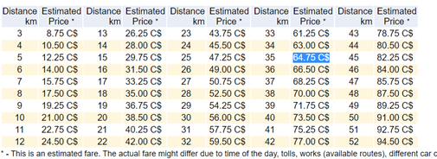
Round 34.8 km to 35km = $64.75

