­­

**Electoral System Requires Reform**

After winning a larger portion of Canada’s votes, Conservatives are kept from the office by the Liberals once more.

**Liberals Pull Ahead After Divisive Election**

**NDP Calls for Reform**

After this election, the Conservatives aren’t the only party disappointed by the electoral system. NDP party leader “Jagmeet Singh”, has publicly voiced his opinion. “The New Democrat party will be constructive and will respect the choices Canadians have made,” Singh told reporters Tuesday. “The results show a broken electoral system and it’s certainly clear we need to fix it. I’ve long called for and will continue to call for true electoral reform.” Such a statement is understandable, considering “NDP” was able to generate more than double the votes that “Bloc Quebecois” received, yet still won significantly less seats. Had this been different, than the New Democratic Party would have been better represented in this election.

**Will There be an Electoral Reform?**

At this point, various party leaders have brought up electoral reform in their statements. Prime Minister Trudeau has made a promise with that topic but failed to follow through. Canada is waiting to see if the Liberals will pick up on this the second time around. Leader of NDP, Jagmeet Singh, has openly stated that he is on board, for he believes that the system is, as he put it, “broken”. Elizabeth May is pushing for electoral reform, for she wishes to lower the age of voting to 16. Though Andrew Scheer has not released his opinion on the topic, many believe that he and his party would follow through, considering that they received the popular vote this election, yet still did not win. With every almost every major political party calling for reform, it seems likely that we will receive such a thing as some point in the future.

**Will Electoral Reform be Difficult?**

Conservatives and NDP are on board for electoral reform as far as we know, yet it seems likely for the time being that Liberals will contend that plan, considering that it is a promise that they dismissed of years ago. If nothing happens and the Liberals remain in power as a minority government, it could prove difficult to pass the law of electoral reform. However, this is not to say that that it would necessarily be in Trudeau’s best interest to fight the movement for reform. **See more information on Page A3.**

**Alberta calls for Separatist Movement**

During the 2019 Federal Election, the Conservatives won nearly every riding in the province of Alberta, and yet still did not win the most seats across the country. After this turn of events, Alberta is now seeking a separatist movement, to remove themselves from the rest of Canada. **See more information on Page A3.**

**Elizabeth May on Electoral Reform**

The leader of the Green Party has also called for electoral reform. However, she elects for a different kind- she wishes to lower the voting age to sixteen, allowing our youth a say in federal elections.

**Why Canada needs Electoral Reform**

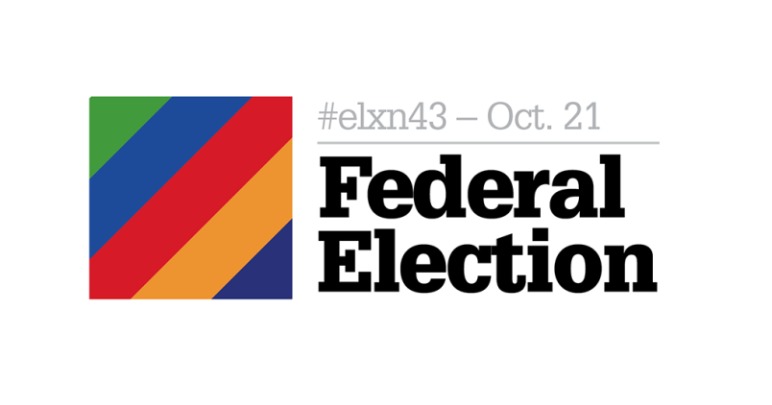

The 2019 Federal Election of Canada has come and gone, with Liberals holding more seats than any other party, forming a minority government. While Conservatives were leading polls by 2% prior to the election and ended up pulling in a million more votes than any other party, they were still outdone by the Liberals, who were able to draw more seats from this election due to the failure of our system. If more Canadian citizens wish to be led by a certain party, then why should their voices be silenced because of a “Ridings System” that they never asked for? **Story continued Page A3.**

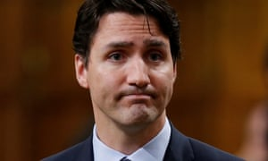

Justin Trudeau is our current Prime Minister, and he may be the worst thing that has ever happened to our country. **See more opinions on Page A3.**

**What will the Conservatives’ Next Move be?**

Currently, the Conservatives do not seem to have any definitive plans in action, for there will not be another election until 2023. In the meantime, however, Leader “Andrew Scheer” has gone on record saying “While tonight's result isn't what we wanted, I'm also incredibly proud, proud of our team and proud of the bigger and stronger Conservative team that we'll send to Ottawa,". The Conservatives appear to remain confident that they will have another shot at winning in the next election, and are hoping for a majority government, as they were this time. At this point in our country, with the reaction to this year’s election, no one would argue that the conservatives have a real chance at taking the most seats next time. Canada will have to wait and see.

The Vancouver News Port

October 23rd, 2019