Health
I will try to spend around 4 or more on health a week. I could go on walks with my family and do some light exercises at home. Also making sure to incorporate some fruits and vegetables in my meals.
Education
I would like to spend around 3 hours a week on education. I’ll take care of my education by making sure that all my notes and papers are organized so I can find them quickly when I need them. Also taking more time on assignments so I could put more effort into them.
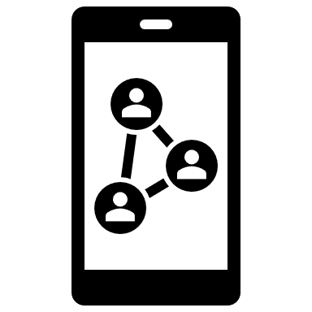
Social Bonds
I could spend around 7 hours or more focusing on social bonds. Like having a conversation with my family during dinner time or talking and helping out peers at school. I can also be messaging friends on social media to see what they have been up too.
Stopping Rules
-School
A rule could be that if you’re allowed to use your phone in class, you could double check all of your work/notes to see if you could be using your time wiser. Another rule I could have is to just keep my phone in my backpack so that I’ll have less of an urge to grab it when I don’t need it.
-Home
At home we already have this rule where you are not allowed to use your device if it has low battery. Let it charge and then you can use it. Another rule could be to set an alarm or timer on your device and then switch to the television. So it would be more of a slow transition into doing something else.

