Canadiana:
A Series of Speculations

Kate Lee
633983
AP English 11
Mr. Kevin Wallace
Canadiana Project
08/06/2020

Introduction
“Canadiana: A Series of Speculations” presents the underlying theme of speculatory voices attempting to piece together works that depict human thought, behaviour, and interaction both internally and externally. From social to familial to personal levels, the discussion around the inability to understand others and oneself is a theme in Canadian literature, while Canadian art illustrates the great unknown of the lands that people conquer by settlement, struggles of isolation, vivid representations of alter egos, the dreams of dreamers and the bleak journey that lies ahead for anyone attempting to understand with further clarity the cognitive process of and others.
Such a vast selection of themes is only made possible by the extensive range of contributors and their experiences, thoughts, and analyses, and even then, it is important to acknowledge the void of works that did not make it onto paper or canvas to be branded as Canadian. On behalf of these people who were and are unable to exhibit their part, other Canadians commit to writing and painting to describe their joys and sufferings, their confusions and breakthroughs, and the love and hate relationships they cultivate with the condition called life.
Every other composition is accompanied by a Canadian painting. Each art essay does not necessarily analyse the piece but draws from elements of the imagery to relate its components to the respective topic, with two of them synthesizing with Canadian biographies. Each composition is relevant to the those directly around it, and they work together to create a greater analysis of Canadiana. Additionally, a review of art follows the concluding abstract of this project, which may seem anomalous but serves to keep the formatting of the overall piece consistent, as contradicting as it may seem.
Beginning with a discussion on settlement and carrying on to examine the life conditions that affect people’s lives and attitudes, the first subject of discussion revolves around communal relationships, both human and environmental. To explore the interconnection between the self and other with a few examples of xenophobic treatment and harsh, new environments, prominent Canadian novels and short stories narrate a reasons and motivations behind the behaviour toward others.
The scope then narrows and dives into the issues of isolation, identities, and alter-egos, focusing on the familial thoughts and behaviours of people who are intimately bonded. From art interpretations that elaborate on how the universally experienced feeling of isolation is not solely a feeling, but a circumstance of life, to texts that demonstrate how identity crises are often directly linked to deranged alter-egos, the horrors and idiosyncrasy of the non-public, individual conduct individuals among only their closest kin touch on the oddity of the thought process that accompanies a sense of security.
Finally, a scrutiny on a personal, internal level draws from the previous examinations of communal and familial relationship to exemplify how Canadian texts boast of extensive insight into how delusion and dreams are a lonely and relentless journey.
Overall, “Canadiana: A Series of Speculations” is the product of a thorough examination of several prominent Canadian art and literature pieces that summarizes the most notable themes by a sequence of analytical essays, demonstrating how living conditions, social identities, and personal delusion are both overtly and subtly present in these compositions. As each essay observes, synthesizes, and analyses a variety of texts, the consequential realisation comes with acknowledging that as deep and as broad the discussions around understanding human relationships are, they are – in terms of the etymological old French, imparfait, and from Latin, imperfectus – imperfect, in the sense of “unfinished, incomplete, and immature.” The incomplete nature does not take away from the quality of Canadian works, rather, it is the condition that is often overlooked and treated as accurate and wholesome, when they are merely limited attempts to grasp at the reality in which contributors and subjects exist.

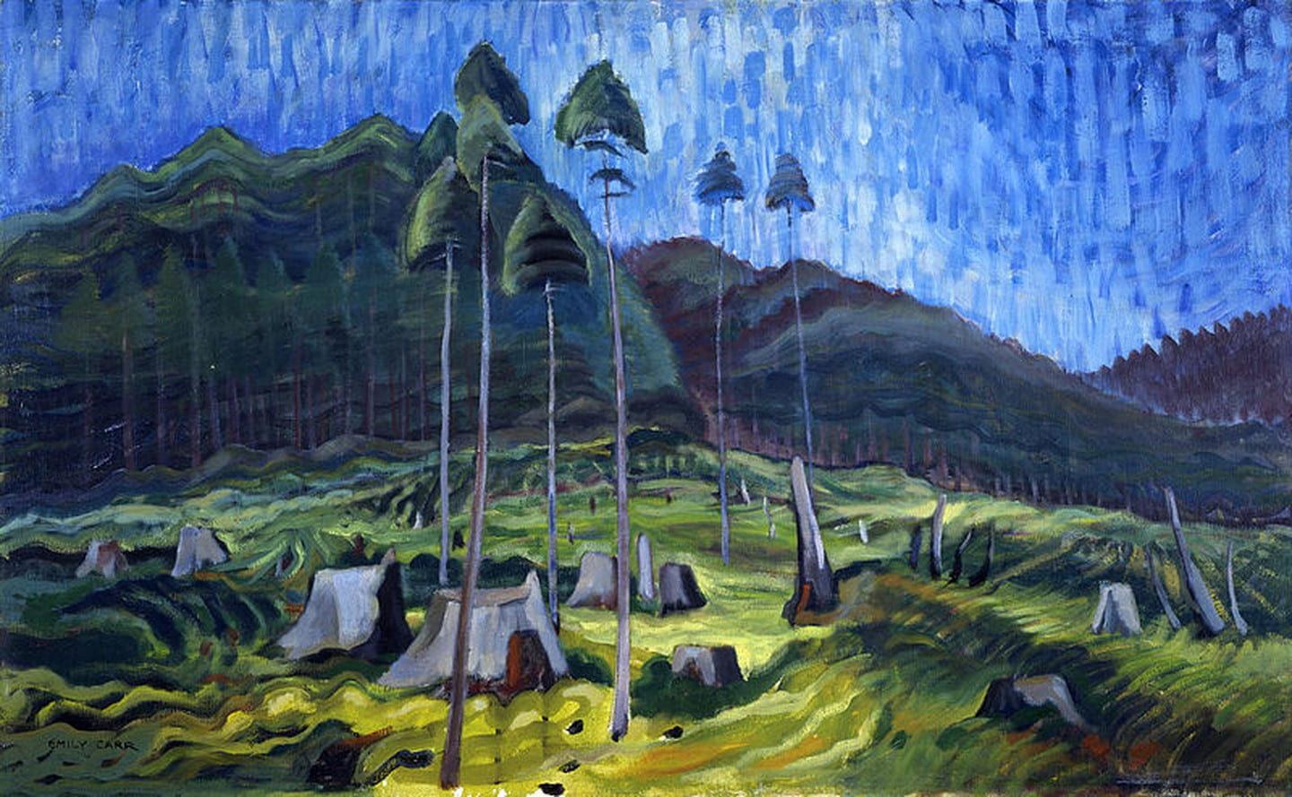
Settlement
Odds and Ends By Emily Carr (1939)
Emily Carr’s painting Odds and Ends is the epitome of an unconquerable environment. On a smudge blue sky, tree stumps dot the lush moss of the landscape while sickly thin birches growing through the logging stand weak and fragile. While post-clearing stumps of ancient trees occupy half the painting, pine-covered mountains saturate the other half. Loggers do not begin clearing such terrains to mow the entire landscape of trees, but they log to make a livable place for themselves. Similarly, many pieces of Canadian art depict the struggles of immigratory settlement into foreign societies and the challenges of finding or having to pioneer a culture of acceptance in new communities.
Odds and Ends relays through art the experiential distance that Susanna Moodie felt from her home in England when she arrived in Canada, as well as the separation that the Ukrainian mother or Chinese boy or Iranian lady endured from home. Perhaps they do not know the language, are alone or have little money. Absolutely, there will be frauds, thieves, and corruption at every wrong turn, yet all the same, there will be immigration services, familiar communities, and kind people to help new arrivals feel at home. Regardless of motives to immigrate, settlers are just as accompanied as they are alone.
In terms of Odds and Ends, every new settler is stepping into a forest. They may have never lived in such a wild environment as this, but just as people before them were able to inhabit the logging town thirty miles north under the same conditions, the settlers should be determined to not only make a living but flourish where they are. There are, of course, ravenous wolves, grumpy bears, and poisonous mushrooms, but there are also streams of freshwater, ripe blackberries on bushes, and non-poisonous mushrooms. Until they take up courage and conquer the land on its terms by clearing trees, setting up camp, and finding food to eat, they cannot truly settle onto the land.
But even after they have cleared their share of trees, there will always be an endless thicket beyond their bounds. Their resolved problems will only face more obstruction than fathomed.
Furthermore, it is upon acknowledging the perpetual, environmental challenges that the settlers can begin to accept and feel acceptance from their communities. Take Jack Hodgins’s Broken Ground, where the families of post First World War veterans from cultures all across Canada took up the government’s promise of free farming land on Vancouver Island and populated the Portuguese Creek settlement. Despite the arduous toil of the people, the land was desolate and fruitless, and the obstinate nature of the deeply rooted trees demanded perilous explosives to clear the area, but it was the forest fire that touched their community and took the life a little girl that proved to be the event that finally established a sense of community.
The uprooting of an individual’s former roots and the courage and willingness to lay down roots where they settle drives them to become a local community. Even as the loggers of Odds and Ends were unable to uproot the stumps with simply an axe, and nor were the settling “farmers” of the families in Broken Ground, roots are the stubborn treasure that individuals carry to remember and learn of surrender if they desire acceptance in their new communities.
Thus the challenges of settling are daunting for both immigrants and relocators, but the struggle of finding acceptance binds all of their circumstances together. As Odds and Ends has a shadowy, intimidating landscape that seems impossible to conquer, yet is filled with fragments of light that promise warmth, settlers who understand that victory does not lie in defeating the daunting environment, but rather in illuminating their settling communities with flickers of hope, are the ones who successfully pioneer better lives amidst hardship.

Conditions
Many claim that attitude is everything, and that living conditions and circumstances are merely tests that build character. Nevertheless, outcasts who are wounded by discrimination and newcomers who are unwelcomingly oriented are commonplaces. Many Canadian works serve as simulations featuring fictional characters that resemble the authors themselves, with authors ranging from first-generation Jewish-Canadian Mordecai Richler to past second-generation Margaret Atwood, who puts herself in both previous and future Canadians’ shoes to narrate her stories. By their narrative styles of self-application, even fictional works attribute to immense authenticity. They depict the social conditions of Canadian life, addressing the link between settlement and poverty, and how that relationship leads to stigmas that hinder the community’s values, consequently inflicting the scarring consequence of isolation upon those affected.
Immigration with hope for a better life but lack of sufficient funds, a job, or a social network is often what plummets new settlers into poverty. Being a nation built on global immigration from colonists and emigrants to refugees and displaced persons, many Canadians reflect upon their beginnings, but these beginnings collectively share the similarity of sufferings and challenges.
Alexander McLachlan, a Scottish-born Canadian poet, animatedly depicts the perspective of an impoverished stranger in “We Live in a Rickety House.” The rhyme opens and closes with the description of their living space:
We live in a rickety house,
a dirty dismal street,
Where the naked hide from day,
and thieves and drunkards meet.
(McLachlan)

With that indecent imagery, the narrator carries on to mock the further degradation from their local “pious folk.”
When our dens they enter in,
They point to our shirtless backs,
As the fruits of beer and gin.

And they quote us texts, to prove
That our hearts are hard as stone;
And they feed us with the fact,
That the fault is all our own.

And the parson comes and prays –
He’s very concerned ‘bout our souls;
But he never asks, in he coldest days,
How we may be off for coals.
(McLachlan)

Although the recent settlement of the speaker is not explicitly stated, the distance his self-righteous neighbours rigidly set in place by their interactions strongly implies that his people are foreigners to the community. Nevertheless, it is apparent that they are incredibly poor, and their poverty is credited to be “the fruits of beer and gin,” that is, drunkenness, and the likely texts of faith that “prove that [their] hearts are hard as stone” only contribute to further reason for saintly condemnation. To justify the state of the den they entered, the pious folk make it a fact that “the fault is all [their] own.”
Further, it is the parson’s visit that upsets the speaker the most. The visitor’s complete ignorance of his hosts’ physical needs and his sanctimonious concern for their souls anger the speaker, depicting the broken and conflicting relationship of the poor and affluent of the community. One perspective is the direct verbal and spiritual mistreatment and judgement of the impoverished by the pious people, but the other is shrouded hate for the pious by the poor. Their loathing comes with good reason, seeing that there seems to be no attempt by their visitors to hear their story and understand their situation. The pious community values words without action, while the wretched and impoverished sinners seem to value nurturing resentment toward such things.
The link between settlement and poverty is accentuated by the setting and transparency of the speaker’s indignance. Authentic presentation of external comment and internal response is essential in thoroughly evaluating relationships between people caused by the conditions of one or both parties. Despite the speaker’s exasperation toward the parson, they expressed it as no more demeaning than it really was, and then criticized the pious folk for their needless ignorance as they truly felt necessary. Although the immateriality of circumstances and conditions is what gives meaning to the tangible, it is only where there is honest portrayal of what is seen that there is credibility with what is not.
Furthermore, Mordecai Richler’s The Apprenticeship of Duddy Kravitz also portrays the parallels between settlement and community stigmas. Although the novel follows the life of young Duddy Kravitz growing up on St. Urbain St. in Montreal, many of his grandfather Simcha’s stories of settling in Canada pave the road for Kravitz’ own story. When Simcha first arrived, he was not poverty-stricken, and as a shoemaker he was able to send for his family and set up a shop within three years. Moreover, his foreign status did not stop the local district of gentiles and Jews from increasing Simcha’s stature.
Among the other immigrants he was trusted, he was regarded as a man of singular honesty and some wisdom, but he was not loved. He would lend a man money to help him bring over his wife, grudgingly he would agree to settle a dispute or advise a man in trouble, he never repeated a confidence…
Blondin the blacksmith had been kicked by a horse. Simcha, not the first man on the scene, forced Blondin to drink some brandy and set the broken bone in his leg before the doctor came. After that whenever there was an accident… Simcha was sent for. (Richler 45-46)

And while the rest of the chapter informs of Simcha’s good works and the high regard he possessed from his community, he still “was not loved” (45). For a man who seemed to be the manifestation of a good neighbour, his virtue could not surpass his status as a Jewish immigrant. It seems that even a culture of respect and admiration did not learn to love and care for the Jews as their own.
A similar but less noble example comes Margaret Atwood’s The Journals of Susanna Moodie, where Atwood wrote a series of poems narrated from the perspective of Susanna Moodie, who was a prominent nineteenth-century colonist-Canadian author that often complained bitterly about the difficulties of getting settled in Canada. One of the poems in the journals is called “First Neighbours,” and Atwood, borrowing Moodie’s voice, speaks of how “[t]he people I live among, unforgivingly / previous to me” (46) would grudge the way she breathed the air of the property on which she lived. This grievance was not whimsical on part of the Indians who lived in her area, rather, Moodie had settled in the British colony that had a dishonest relationship with the natives.
Despite her attempt to “adapt,” she was told to “[g]o back where you came from,” and this hurt her because she “knew that England was / now unreachable” (46). As the poem carries on, Moodie
got used to being
a minor invalid, expected to make
inept remarks,
futile and spastic gestures
(Atwood 46)

but that she also “grew a chapped tarpaulin / skin” (46), demonstrating her resilience against her scars. The irony lies in her self-address as a minority while the white colonists thrived in the nation, as well as her confession of submission to the local’s expectations of her behaviour. Even while Moodie’s act was traumatic for her, her greatest difficulty is the discrimination she faced from the community.
For a nation internationally reputable for its politeness, the factual and fictional Canadian testimonials of the people who built this country affirm the contrary. The authors who contributed to the characterization of Canadiana’s social living conditions amongst a community made clear that the bond between settlement and poverty are not easily severed, and that communities develop stigmas to outline borders within itself, and that isolated peoples are wounded by the discrimination they experience. While attitude is a key factor in the growth of an individual’s character, it serves as no excuse to ignore one’s living conditions and deny them communal acceptance. Hidden in the plethora of Canadian stories to poems to paintings, the gem of solemn advocation for any foreign individual rejected by their community exists unostentatiously for anyone who will observe and listen.

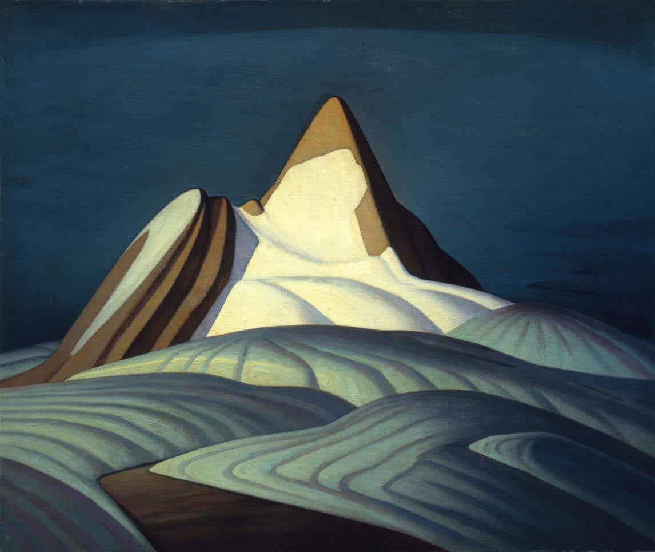
Isolation
Isolation Peak By Lawren Harris (1930)
A mountain stands alone with snow slipping off its peak in a field swimming with white hills. The peak is all a person and an idea, a motive, a thought. By casting dramatically detached imagery from the centerpiece and the environment, Lawren Harris’s Isolation Peak, Rocky Mountains, and Northrop Frye’s biography in The Canadians: Biographies of a Nation relate the purpose of isolation in Canadiana’s extensive framework.
In like manner to the solitary peak in Harris’s painting, every person is the isolated peak in their own life. No one has, is, or ever will journey through life with a permanent, human other. Take the love of Northrop Frye’s life, Helen Kemp. Although they were married over fifty years before she passed away, she was not with him at his birth or death. Even his profound visionary, dream-like experiences he could not share with her. Of course, recording such experiences as stories and biographies can retell the experienced events, but such retellings do not come close to the real experience.
at the heart of [Frye’s] work is a series of sudden flashes of what seemed to Frye to be profound and intricate insights that would require a vast amount of rigorous thinking to explore and to make comprehensible both to himself and to others…
one day on his way home from school was struck by a sort of spiritual and intellectual searchlight beam. He said that he had known at the time it would take him years to find out what the sudden clarity meant, but he also knew right then and there that it would change his life. (Watson 191-192)

And the work that revolves around Frye’s flashes has drawn the universal attention and rigor to understand his interpretation of literary criticism and numerous other subjects such as myths and metaphors and religion of every respectable English scholar and many English students.
Despite a journal entry that he wrote on his sixtieth birthday reading, “I have arranged my life so that nothing has ever happened to me, and no biographer could possibly have taken the smallest interest in me” (190), he became one of the most influential literary critics and theorists of his time. Often, without knowing in their lifetime, people assume that their stories and lives are as average as humanly possible, simply because they feel they are being themselves, and since everyone else is themselves, every human life on earth contributes to the heap of similarity.
Although Frye’s work happens to be influential and his legacy remains unmatched, his life story serves as a guide to understanding the theme of isolation in Canadian literature and art. When writers and artists set about with their work, very few achieve exactly what they had in mind, since even what they had in mind was likely an incomplete thought or a vague aim. But as the story feeds off the inspirations and ideas of the creator, it grows and matures to become its own, unique being, existing as a sole entity in the universe.
From Isolation Peak to biographies and novels, every Canadian work is the product of a distinct mind, one that is isolated not because others are not, but because in their psyche no one can completely join them. Even copied ideas are formed from idiosyncratic motives and feelings, unparalleled for eternity because of the singular circumstances and situations of the artist.

Identity
While the world tells each person what they should believe and how they should behave and what code of morals they should adopt, the free people are the ones who can be shaped by the whirlwind of pressures but tolerate it with independent thought. By their mindful discerning of which values to embrace and how to live their lives, cultures evolve and challenge society’s standard norms of life. Canadiana candidly portrays demonstrations of integrity toward individual roots by assertions of independence from family values, and how escape or isolation from kin is how they can remain faithful to their own identities in peace.
In several excerpts of Mordecai Richler’s The Apprenticeship of Duddy Kravitz, the audience learns of Duddy Kravitz’s Uncle Benjy, the son of Kravitz’s grandfather Simcha. Simcha arrived in Montreal first, and after working for a few years, brought over his wife and two sons. And his first son, Benjy Kravitz, life pioneered the culture of independence as he grew up in a Jewish concentrated milieu.
While the whole community saw how much Simcha adored his son and saw how “[o]n Saturday mornings father and son could be seen standing side by side in the synagogue”, upon beginning “to read Mencken and Dreiser,” Benjy “no longer came to pray” in the synagogue. Benjy must have been aware of the reproachful chatter of the devout Jewish community around him because “the other old men became sad and gentle with him [giving him] sympathetic looks” (47), but he lived “without fear of the new country” (46), putting the only people he could call his own behind his faith. Benjy’s credo consisted of more than his family’s influence, filled with ideologies and values that he developed while maturing to become a man of his own making.
Furthermore, his unyielding values led to a broken marriage and the sacrifice of relationships with beloved kin. His wife Ida wanted children, but he did not, and when the two found out that she was barren, Benjy told his father that he was impotent and telling his wife that he did so “‘because he loved and wanted to protect [her]’” (237). Benjy’s tender treatment and care of her led to Ida feeling worthless, and when she took to travelling for long periods, having affairs with different lovers, and they no longer lived together, Benjy withdrew from his father and took to drinking and living alone. As much as he loved Ida and his father, it was only by self-isolation that he could avoid the bitter conflict of the incompatibilities of their characters and desires altogether. In devotion to his values he kept his peace.
Likewise, two young women in Thomas King’s Medicine River boldly live out their lives as independent women who do not conform their identities to any is narrated by the thoughts and interactions of half-Blackfoot Will Horse Capture, a photographer who lived in Toronto until his mother’s death brought him home to Medicine River.
He met his first lover Susan when he was taking candids at a gallery exhibit for his friend. Despite Susan’s cold response to his greeting upon their first encounter, by the second time they met, they began to go out and frequently made love at Will’s apartment with him unaware of Susan’s caring husband and two young daughters. Upon calling her line when he could not reach her work number one day, he discovered that Susan had a family. After Susan explained to Will that she loved him and finally mustered the courage to leave her family, she came over to his apartment for an evening, but when Will returned home after work the next day, “Susan wasn’t there. She had come by sometime in the afternoon, collected her things, and left” (179). Will felt that she had “left everyone. She had left Ralph. She had left her children” (215) and was especially hurt and bitter that she had left no trace for him to contact her.
Six months after she left his apartment for the last time, she called him, told him about how she now had a new job and a new house, and how she had remained friends with her husband throughout the process of divorce. When she finally invited him to dinner at her place, he agreed to come with the notion that it would just be the two of them and was ready to tell her how he truly felt and no longer “be needed the way Susan needed [him]” (213), but upon arriving he found the house full of people that Susan had invited for to celebrate her self-redemption in life.
As Susan greeted him and took him around the house for a tour, she told Will that she was sorry about the way she left, confessing that
“I needed to get away. It wasn’t just Ralph. It was me. I kept giving my life away to people. To Ralph. To you. There was nothing left for me.
“You know what I’ve discovered? I don’t really have to have someone. I can do everything myself. Men are used to that, but I never knew I could do it all by myself. Life, I mean…
“Things have changed Will. I have a job, a house, my two girls, and a new life. It’s kind of exciting. You know what I mean?” (King 220-221)

And Susan went on to introduce Will to Ralph that evening and carried on hosting the night.
However, by the people who attended her dinner, it seems that it was Susan’s own decision to give her life away. Perhaps as she pursued life on her own, abandoning her reputation, her family, and her lover, she came to acknowledge that it had not been the people who had treated her poorly. Rather, as she reveals to Will, she realised that it had been in her own nature to give herself away, and by secluding herself from those she cared about, she was able to truly pursue living for herself.
After Will closed his relationship with Susan, he left Toronto and headed to Medicine River. Although he insisted that he liked being single, when he listened to his friend’s advice to take out Louise Heavyman, an accountant on the reserve who was pitied lately because her Cree boyfriend had impregnated and left her, Louise asked, “‘[h]ow about I pay for my own meal?’” and, “‘say I pick you up around six-thirty?’” before agreeing to go out (32). They began having dinner together weekly, and as Louise shared with Will that her boyfriend had thought she would marry him if he impregnated her, but when she declined his proposal after he had done so, he had left. She also revealed that she had wanted a child but no husband, hinting to Will that even if she liked him, they likely would not marry.
When Louise began to labour, Will took her to the hospital and unintentionally named the baby South Wing after the hospital wing where she was conceived and Will himself was mistaken by the nurses as Mr. Heavyman. After Louise recovered from giving birth, they fell for each other and enjoyed spending time together, but outwardly, neither wanted to marry or commit to moving in together. When Louise asked Will for help in finding a house, a realtor that toured them inexplicitly disapproved of their relationship because they were neither married nor officially together but had Louise’s daughter South Wing with them. Will saw that Louise was unashamed of her choices and was someone who “‘speaks her mind’” and “‘knows what she wants’” (208), and implicitly credited the surety of her decisions to her values. She defied the conventional norms of familial conventions, refusing the label of a dependant single mother and making choices on her own, never known to have asked “‘anyone for advice… about having South Wing or becoming an accountant’” (210). By steering her life clear of commitment while enjoying what she wanted, she proved her loyalty toward her moral code of female power. Both Louise and Susan found a way to live independently from traditional familial pressures, influence, and demand, regardless of how absurd their rationalizations are for why they did so.
Moreover, defiant independence toward family values is not limited to young people. In “To Set Our House in Order,” Grandmother McLeod lives with her son’s family during the Depression, where food is scarce and there is little to no economic flow of money. She recalls her younger days when her husband was still alive and she “‘never had less than twelve guests for dinner parties’” (588), and her yearning for the days of lavish hosting insinuate that she believes that it is ultimately possible, even though she may wring her son’s family of their money, to make her sumptuous past her present once again. She lectures to her granddaughter, the narrator of the story, about how her father used to say to her as a girl that “‘God loves order’” and that because “‘he wants each of one of us to set our house in order’” (588), she justifies her unending orders of “three linen tea-cloths and two dozen serviettes” (589) by claiming it to be consistent with the order of the house. In doing so she is seemingly unaware of the financial difficulty of her family, blindly steadfast to the past that she believes defines her in the present.
Another consistency that Grandmother McLeod keeps to remain in the past is her opinion on the linguistic evolution of her son’s generation. She cannot afford to hire a girl to help with the housework, but she “‘can’t bear slang’” (588) either, so when her daughter-in-law’s sister, who “‘speaks in such a slangy way’” (589) comes in to set the house in order, Grandmother McLeod self-isolates in her room for the entirety of the cleaning and then comes down only when she has an order for “two-dozen lace bordered handkerchiefs of pure Irish linen” (590). She distances herself from Edna to keep her ears clean of the filthy language that she cannot tolerate, and so keeps a clear conscience before her God who loves order, the order in this context being good English grammar.
Grandmother McLeod loathes change in the order of her lifestyle more than simply despising slang or keeping ignorant of the reality of the Depression. Regardless of the incomeless state of her household, she remains faithful to the version of “‘God loves order’” (588), and she carries on ordering from the “‘catalogue from Robinson & Cleaver’” (589) with complete confidence that she is only doing what God loves.
Pioneering identities means leaving everyone else behind in one’s journey, and wherever there is a pursuit for independence, the commitment of level of treatment for the people in one’s life narrows to focus on the commitment of integrity toward individual values. While others often view this as selfish and overlooking of familial responsibilities, to those who consider maintaining integrity toward their core values as the most important part of their lives, they will pursue such lifestyles without hindrance. Their principles hold them fast as they sacrifice family, relationships, and seclusion to make their statements. Canadiana reflects the condition of many Canadians as they endure hardship to stay true to their principles in the many different faces of opposition.

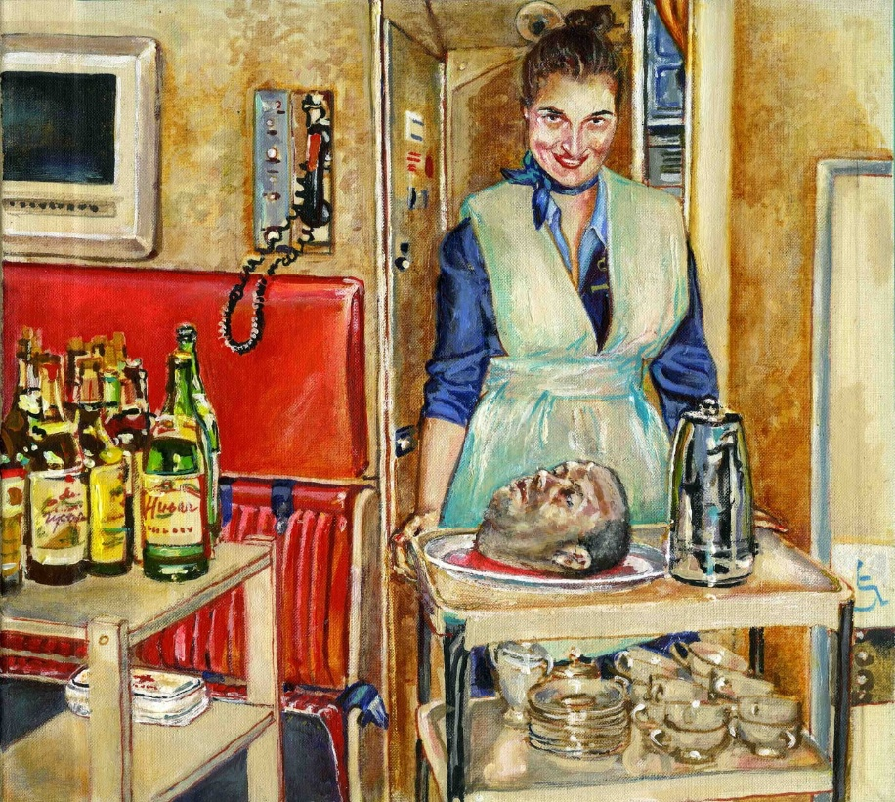
Alter Ego
Poetic Justice By Natalka Husar (2016)
Natalka Husar’s Poetic Justice shows a young woman in an airplane’s hallway with a cheery, blushed face, but her hands rest on a rolling cart before her with the head of a man in a pool of blood acting as the main dish that she is serving. She emerges from the darkest opening from the drab and fading yellow walls, the blackness of her eyes being accented by the vermillion shadows beneath them. If there had been another dish, she looks as if she would have been very proud of what she had on the cart.
While Husar, by the normalcy of everything else besides the head on the plate, contrasts sanity and insanity on one canvas, in Patrick Watson’s non-fiction broadcast manuscripts The Canadians: Biographies of a Nation featuring the biographies of prominent Canadians explore the shallow roots of the dark alter egos and how they develop in harmony with the socially acceptable side of individuals, and finally, the delusion that overwhelms them to abandon their sane identities.
As the young woman in the photo smiles with an excited, fiery glare from her eyes. She wears her light blue blouse nearly unbuttoned and unabashed, and her deep blue jacket, matching scarf, and bold makeup resemble the uniform of a flight attendant, whose work is associated with diligent customer care and service. Whether she is the one who executed the man or someone else did the job seems irrelevant as to how she feels about it – her expression shows no sign of sickness or nausea while she confidently poses with her prize.
However, Husar creates a setting that makes the background as bold as the woman’s figure. As bold as the blue of her uniform is the scarlet red of the seats flight attendant seats behind her. The clear greens and browns of whiskey bottles fill the top of a trolley next to her, defying the abnormality of the head that sits on her own. The typical setting around her represents another part of her conscience – the peaceful, dutiful attendant – while the striking shades of horror on her cart depicts the savage mentality attempting to coexist in her nature.
Ultimately, no matter how balanced the forces of the conventional setting wrestle with her macabre presentation, for the audience, everything around the woman fades away as she emerges into the spotlight. Likewise, In the woman’s mind, she casts out the identity she nurtured with every social value she learned to integrate into her life when she begins embracing slaughter with the proud smile she has stricken on her face. She no longer knows guilt as her murderous alter ego takes over her entire mentality.
Contrastingly, part four of The Canadians: Biographies of a Nation testifies of how the alter ego of Alma Pakenham, the wife of British Columbia’s parliamentary architect Francis Rattenbury, drove her demurely complexion to face her deceptive, unforgiving, and suicidal character.
When Pakenham moved with her husband to England after her husband was shunned for mistreating his previous wife to be with the ten years his junior singer and songwriter Pakenham, their love grew cold and Alma began to have an affair with their young servant George Stoner. While Pakenham was truly a dignified lady of class and mannerism, Stoner was not, so when Stoner began complaining to her that he did not enjoy being both a lover and a servant, Pakenham was worried that he would act out and asked her husband for 250 pounds for a “woman’s operation.” With the money she drove out with Stoner to Kensington and shopped, drank, and took him to bed at the Kensington Palace Hotel.
Upon their return, Pakenham was relieved to find her husband feeling well, and when she saw that he was drunk, she felt some of her old affection for him and helped him into his bedroom. It was when she closed the door that Stoner, who was stoned, was livid and full of jealousy. The next morning, he took a carpenter’s mallet up behind Rattenbury in his room and brought down the mallet onto his head three times. He was not killed immediately, but the blows hurt him badly and he died later that day.
Immediately after smashing Rattenbury’s head, Stoner rushed to Pakenham’s bed and implicitly told her that he had murdered her husband, and by the time the doctor arrived, she was sitting next to her dead husband, got drunk, and deludedly claimed to have murdered her husband. Whether she intended to protect Stoner from being charged out of her love for him or she felt that it was her decisions that murdered Rattenbury, Pakenham blamed herself for his death by pleading guilty in court.
However, when she was before the jury, she seemed to be in her right mind. Rather than the seductive girl they expected to see, they were met with a well-behaved, respectable lady. Yet she continued to plead guilty until Stoner turned himself in, and Pakenham was proven to be innocent while Stoner was convicted of murder.
Pakenham did not let the murder go. Her distress drove her into depression, and she committed suicide by taking a day out to go shopping, buying a knife, and plunging it into her chest at the edge of a riverbank.
Although it was unlike her known social character for her to end her life in that way, what she did not reveal to others was the exhausted and hopeless self-condemnation that ebbed away at her conscience each time she acted against her standard code of conduct. And while standards like marriage and infidelity became numb to her moral sense, murder was not a crime she was prepared to be associated with. To cope with her lover’s homicide of her husband, she needed to abandon her virtuous judgement and turn to her insanity.
Therefore, despite the difference in the backgrounds of Husar’s woman and Pakenham, both of them become unfeeling to the violation of their values, and when they begin to embrace the more immoral and wrongful alter ego, they find themselves having to turn to it completely as it does not tolerate compromise with virtuous thoughts and actions. While the ending leads to a tragic death or the death of one’s compassion, the conclusion is that they no longer embrace their sane character. Holding onto the virtuous and refusing for the two sides to balance is the only way to keep from self-destruction.

Delusion
For so deep were his instincts of loyalty to the land that still, even with the images of his betrayal stark upon his mind, his concern was how to withstand her, how to go on again and justify himself. It had not occurred to him yet that he might or should abandon the land. He had lived with it too long. Rather was his impulse still to defend it - as a man defends against the scorn of stranger even his most worthless kin. (Ross, The Lamp)

Canadiana fiction, poetry, and art begin to tackle the complicated discussion of delusion on a personal level. By juxtaposing the thoughts of dreamers and realists, Canadiana proves that the contrast between the two is not so extreme in that both have similar capacities for perception and delusion, how it is often a product of disregarding voices of alter egos and illustrate delusion to be synonymous with insanity.
An example that encompasses the prevalent aspects of delusion is in Sinclair Ross’s “The Lamp at Noon,” where a couple's conflict demonstrates individual delusions to be more convoluted and depriving of basic understanding, judgment, and sensible perception. Although the couple wed and moved onto the farmland five years ago, the land proved to be unfruitful with dust storms frequently hitting sweeping the area, making Ellen, the wife, “fear… that in the dust-filled air [the baby] might contract pneumonia”. She pleads with her husband Paul to notice the land’s barren condition and urges him to move back to town so that their baby can have a future, but Paul obdurately stands by his vision of a prosperous farm soon. He harshly rebukes her by asserting that it is she “‘who wants to go, it’s not for his sake,’,” condemning her selfish yearning for a posh lifestyle, and the baby as a mere excuse. This hurtful exchange leads to a bitter argument that reveals that Paul cannot assess the land properly and that Ellen, despite caring for her baby, confesses that she also wants to enjoy life in the town. In Ellen’s hurt and anger, she tells Paul that she feels so “caged” and wishes she could only “run” from the burden of her feeling of hopelessness (Ross).
Paul leaves the house for space, throwing aside Ellen’s begging him not to leave her alone, and he heads to the stables. As he “ran his hand over the ribs” of his horses, he “felt a sudden shame, a sting of fear that Ellen might be right in what she said”. In realizing that he couldn’t even feed his horses or properly care for his wife and son, he begins to question if he were only a “blind and stubborn fool” (Ross). As the storm clears away, Paul sees the desolate reality of the land, yet continues to contemplate how he can stay and make life on the farm work.
Meanwhile, Ellen takes her baby and runs into the storm, her attempt seeming like an effort to defy its dominance over the land. She loses her way along with her sanity, and when Paul finds that Ellen and the baby are gone from the house upon his return, he frantically searches for her, only to find Ellen rocking the cold and dead baby in her arms. As he carries them both home, Ellen tells Paul that she thinks he was right, that there will be a good crop soon and they should carry on with life on the farm. Her anguish torments her discernment and by the end of the story metamorphoses it into the same blinding delusion that controls Paul.
By colligating Ellen and Paul’s thoughts and reactions, Ross demonstrates both of their capacities to be blinded by their dreams, also exemplifying marital incompatibility. While it may seem that Ellen was in the right and Paul in the wrong at the beginning, it is important to account for Ellen’s fantasies as well. She dreamt of a comfortable life, with friends and family close by her, and a future for her son. Her dream is not completely selfish or wicked in its nature, but it is this dream that provokes the heated and anguished side of her toward Paul, obstructing her ability to consider Paul’s perspective. As for Paul, his dream is self-explanatory: he feels that he belongs on a farm and that life in town would hurt his pride. Even after he realizes that his vision overwhelmed his judgement, he continues to plot a farm life for his family. To close the story, Ross concludes both of them to be equally convoluted and deranged.
Margaret Laurence’s “To Set Our House in Order” tells of another kind of dreaming and realism that is equally deluding. Vanessa, the child of the family, unintentionally focalizes the family’s struggle through the Depression. Since there is no monetary income, her father, a doctor, and his wife learned to shelve away their comfortable pasts and to compromise with the realities of the present. However, Grandmother MacLeod, the doctor’s mother, remains ignorantly attached to the lavish lifestyle of when she
‘never had less than twelve guests for dinner parties. When [she] had tea, it would always be twenty or thirty. Never any less than half a dozen different kinds of cake were ever served in this house…’ (Laurence 588)

And she continues by adding that, “‘Well, no one seems to bother much these days. Too lazy, I suppose’” (Laurence 588), suggesting that she truly believed it was the fault of Vanessa’s father and mother for being lazy that there were no more tea parties with pretty cakes. She completely neglects the economic situation and channels her criticism to the rest of her family.
As for Vanessa, her young age makes her delusion exceptionally naïve. When her pregnant mother is having labour pains and Vanessa visits her before she is taken away, her mother assures her that everything will be fine and that Grandmother MacLeod will be there for the family. Vanessa, fixing on the first thing that came to mind, wailed, “‘How can she get the meals? …She never cooks. She doesn’t know how.’” (585). Vanessa’s disorientation is rooted in her grandmother’s idleness when it comes to housework, and she honestly believes that Grandmother MacLeod is good for nothing. When her mother leaves the house for the hospital, Vanessa seeks out
hidden places in the house… odd-shaped nooks under the stairs, small and loosely nailed-up doors at the back of clothes closets, leading to dusty tunnels and forgotten recesses in the heart of the house where the only things actually to be seen were drab oil paintings stacked upon the rafters, and trunks full of out-moded clothing and old photograph albums. (Laurence 586)

Hiding from the light and crawling into darker, shrouded places, she attempts to cling onto the past, a safe space where every pain and struggle has already been endured and overcome. She feels that by seeking refuge in the past, her present problems will resolve themselves, in fleeting moments joining the gone past.
Both Vanessa and Grandmother MacLeod quixotically believe that the way of the past is better than the present and that since the future is what they are living in every moment, it becomes the same as the unwanted present. Whether it be conscious or unconsciously, Grandmother MacLeod’s refusal to accept the changes of reality keeps her buying “‘three linen cloths and two dozen serviettes… for fourteen dollars’” (589) and “two dozen lace-bordered handkerchiefs of pure Irish linen” (590), as well as hiring girls for housework when her son makes it clear that he “‘can’t possibly pay anyone’” (589). Grandmother MacLeod and Vanessa have lost or have not yet gained any intention of learning to adjust to their new lifestyles.
Finally, Bronwen Wallace’s “The Woman in this Poem” embodies a delusion that lacks outward expression. The woman in the poem in appearance has a perfect life, with a home and a family and everything in between, but her unhappiness consumes her as she wishes something more than what she has will happen. She writes to her lover in another city and longs to be with him, even reaching “for the phone / to dial the airport,” thinking to herself that
she will leave this afternoon
her suitcase packed
with a few light clothes
(Wallace 937)

but ends up remembering that she has a family and so “stops dialing and begins / to chop onions for the pot-roast” (938). Even as she continues preparing for her husband’s return home, the children’s appointments and dinner, her thoughts drift to that evening, of how
all through dinner
her mouth will laugh and chatter
while she walks with her love
on a beach somewhere (Wallace 938)

Wallace makes it clear that it is not explicitly her lover that she wants to be with, but her desire is for “something,” “anything / to happen.” She offers possibilities of what the woman could do, such as locking herself in a closet for days or
Cruising the streets at night
In her husband’s car
Picking up teenage boys
And fucking them in the back seat (Wallace 938)

But she remains at home, making her pot roast miserably. She does not explore her delusion, which is very much present, enticing itself to her every thought – yet it is her firm belief that the happiness of her family is more important than her own that keeps her where she is. Her delusion is that in staying on the barren farm, there will be a day where she accustoms to the feelings of oppression and imprisonment she experiences there. The woman’s delusion is selfless, but it is a disturbing misconception.
Ross, Laurence, and Wallace’s works contribute to the vast collections of Canadiana that discuss delusional thoughts and behaviours. Delusion is often a direct effect of hopeless dreams, wrecked realities, or the dismissal of the voice of one’s alter ego, which serves to complement each person’s dominant personality. When characters within the narratives tell the story, audiences can directly correlate outward speech and actions to the kind of delusion that restrains them, but it is only when an omniscient author tells the stories of reserved people that anyone can understand the internal delusion that is kept silent. These works remind the readers not to approach scorn deluded people, rather recognize and acknowledge that every individual endures the inexpressible multitudes of hardships that are unknown to the rest of the world.
‘Why can’t she be nice to us for a change?’ I burst out. ‘We’re always the ones who have to be nice to her.’
My father put his hand down and slowly tilted my head until I was forced to look at him.
‘Vanessa,’ he said, ‘she’s had troubles in her life which you really don’t know much about. That’s why she gets migraine sometimes and has to go to bed. It’s not easy for her these days, either – the house is still the same, so she thinks other things should be, too. It hurts her when she finds they aren’t.’ (Laurence 592)

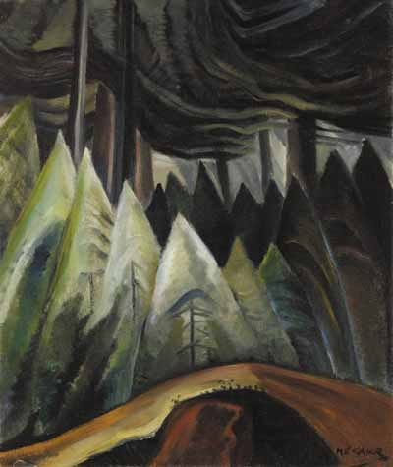
Dreamers
Forest Light By Emily Carr (1928)
Forest Light Emily Carr parallels the lives of dreamers in Canadian literature. By narrating the account of dreamers who hold onto their imagination and refuse to let go even when their decisions disappoint the world of more realists, Carr’s painting reaches out to audiences who find a light in the darkness and meaning in the nonsense of the world.
Often described as stubborn or crazy, dreamers defy the norms of thought by trailing off into the worlds that they created and fostered in their heads and hearts. It is not every thought that they accumulate to build their worlds of dreams, but rather they put to light what they want to keep and cherish, and from there they give everything they have on the line to keep their dream in the spotlight and to fulfill it.
Likewise, Forest Light features a dark setting of swirling treetops and shadowy silhouettes of pines but standing short and stout at the very center of the piece is a bright, almost white tree, mounted upon a gentle, rocky yellow hill. The canvas of the painting represents the canvas of a mind, and the brightness of the dream that illuminates the dim around it stands as the glorious objective of the dreamer amongst the multitudinous hopeless paths that may encompass it.
But as the piece shows clearly, such beautiful dreams are never alone. Just as a light that shines in the darkness is unhidden, whatever light is illuminating the center tree is also brightening other trees around it. When dreamers hold onto a sure hope, which is what dreams become when they are watered with faith, they no longer hang on to the possibility of a fairy tale and continue their journey, but when they surrender every ambition that is not related to their dream, their resilience is rewarded greatly with their hope becoming more assured with the company of more confidence.
Therefore, Forest Light encapsulates the stories of faithful pursuers of visions that empower themselves and the people around them with hope. Speaking for people of all races, all statuses, and all living conditions, the stories of dreamers that were successful in committing to their dreams – not necessarily succeeding in or fulfilling them – cast more than a light on themselves, rather, they too share the light of promise generously with the realists around them. However, even then, the dreams are dreams, no matter how real they become to the dreamer.

Conclusion
“Canadiana: Series of Speculations” scrutinizes Canadian art and literature and presents the steadily present and major themes of Canadiana. The individual topics within the project alternate between analyses of literature and art, with consolidated theses of art pieces by the accompaniment of Canadian biographies. From this exploration, themes of condition, identity, and delusion demonstrate how Canadiana’s expressions of these issues are mere compromises to reality. While their status as conjectures make them inaccurate in comparison to the truth, in humanity’s desperate attempt for embodying the inexpressible and putting into words the indescribable, the bare glimpses of the complexity of humanity from the works of art and literature are sufficient in fulfilling their purpose.
For Canadian artists and writers who continue to explore and publish works based on issues of the human condition, they must be aware that there is an unceasing journey lying ahead, with themselves being their own only lasting, mortal partner. Understanding that even the most profound attempts to dissect, interpret, and express human relationships on all scales of magnitudes should awaken people to understand that while the experience that mankind endures is unique and individual to mankind alone, they cannot put into words or fully express by art the dimension of feeling and perception in which they exist. The physical and emotional realities of being able to pinch one’s own flesh and feel a sense of overwhelming sadness or joy are as far as we can go, which is to describe. Just as the retelling of an experience is not the experience itself, the descriptions of relationships and conditions of humanity are not the relationships and conditions themselves. They are noble attempts of man to take complete control over the actualities of life, because when beings can embody every detail and truth of their existence in a form where it is sharable with others, then they have complete authority of essence and nature. Canadians contribute with great fortitude to this series of speculations that make up not only Canadian literature, but global texts of the so-called “complete” truth.

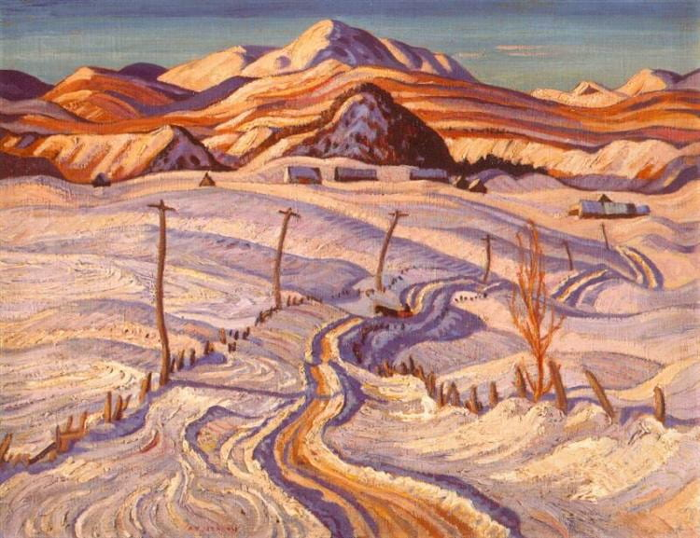
Desert Road
Winter Morning, Charlevoix County By A.Y. Jackson (1933)
Winter Morning, Charlevoix County by A.Y. Jackson is as marvelous as the dream of a child. The sheets of snow cover the landscape of rolling hills and dull mountains, and the drift is coated with the warm glow of morning sun. A rugged line of seemingly parallel fences winds up and down with the hills and tall wooden posts follow along one side of the fences. Houses are in the distance, but too far for the person who is seeing the terrain to get to by foot.
Likewise, the dreams of children are set aglow with the warm glow of their imagination, and the journey they take on their dreams is a long, winding, and eternal path in which they can never find rest despite long travels. They go alone because their imagination is inexpressible through mere words or drawings. It is too full and extraordinary to share even if they tried.
The snow is soft and gentle at first, and as it falls delicately onto the landscape, it only piles up. Children’s storybooks and films fill not only the heads but the hearts of those who listen and allow every lovely idea to compile to their collection of beautiful events and memories that may never have happened.
But soon enough the snow stiffens, and its powdery fluff turns into a kind of stiff ice that is no longer pleasant to travel through nor play in. As the sun’s warmth embraces the landscape each day, the soft orange, yellow, and red glow reflects itself on the snow in vain, knowing fully that it will not melt the snow for a long time, rather harden it.
And when the time comes for the thickened ice to surrender to spring, the snow melts into streams of water, and the trees shake off their white coats, and the hills begin to glisten with the hazy, pale green grass. As children find their dreams fading into reality, the coats of glistening white coats of snow melt away, leaving them to see the barren dirt road and the luscious hills teeming with life.
The sun continues to exude its radiance, a constant reminder of the reality of the landscape’s existence before them.
By the sun’s light, there is hope. Its glow shines onto the very real possibilities of reality, and as the county melts from winter to spring and children’s thoughts from dreams to actuality, the county ages and the children mature. The thoughts keep wandering, and they follow the winding road until they reach rest.
And until their children’s children, there are three other seasons to the wandering that are implied but not depicted in this scenery. In this one captured moment, there is a story of eternity that can never be explored to the end.
Canadiana captures many of these moments, and wanderers of the stories within its arts, music, literature, and biographies will find themselves walking alone on a desert road with the sun rising over them each morning.

Works Cited

Atwood, Margaret. The Journals of Susanna Moodie. Toronto: Macfarlane Walter & Ross, 1997. Print.

Carr, Emily. Forest Light. 1928. Painting. Toronto: National Post. May 28, 2015: March 10, 2020. Web.

––––––––––. Odds and Ends. 1939. Painting. Ukraine: WikiArt. Web.

Harris, Lawren. Isolation Peak, Rocky Mountains. 1930. Painting. Ukraine: WikiArt. Web.

Hodgins, Jack. Broken Ground. Toronto: McClelland & Stewart, 1998. Print.

Husar, Natalka. Poetic Justice. 2016. Painting. London: Culture Trip. Web.

Jackson, A.Y. Winter Morning, Charlevoix County. 1933. Painting. Ukraine: WikiArt. Web.

King, Thomas. Medicine River. Toronto: Penguin Canada, 2005. Web.

Laurence, Margaret. “To Set Our House in Order.” A New Anthology of Canadian Literature in English. Ed. Donna Bennett and Russell Brown. Oxford: OUP, 2002. 584. Print.

McLachlan, Alexander. “We Live in a Rickety House.” Rpo.library.utoronto.ca/. 2011. University of Toronto Libraries. March 10, 2020. Web.

Richler, Mordecai. The Apprenticeship of Duddy Kravitz. Toronto: Penguin Books Canada, 1995. Print.

Ross, Sinclair. The Lamp at Noon and Other Stories. Toronto: McClelland and Stewart, 2010. Print.

Wallace, Bronwen. “The Woman in this Poem.” A New Anthology of Canadian Literature in English. Ed. Donna Bennett and Russell Brown. Oxford: OUP, 2002. 937-939. Print.

Watson, Patrick. The Canadians: Biographies of a Nation. 2 vols. Toronto: McArthur & Company, 2003. Print.

